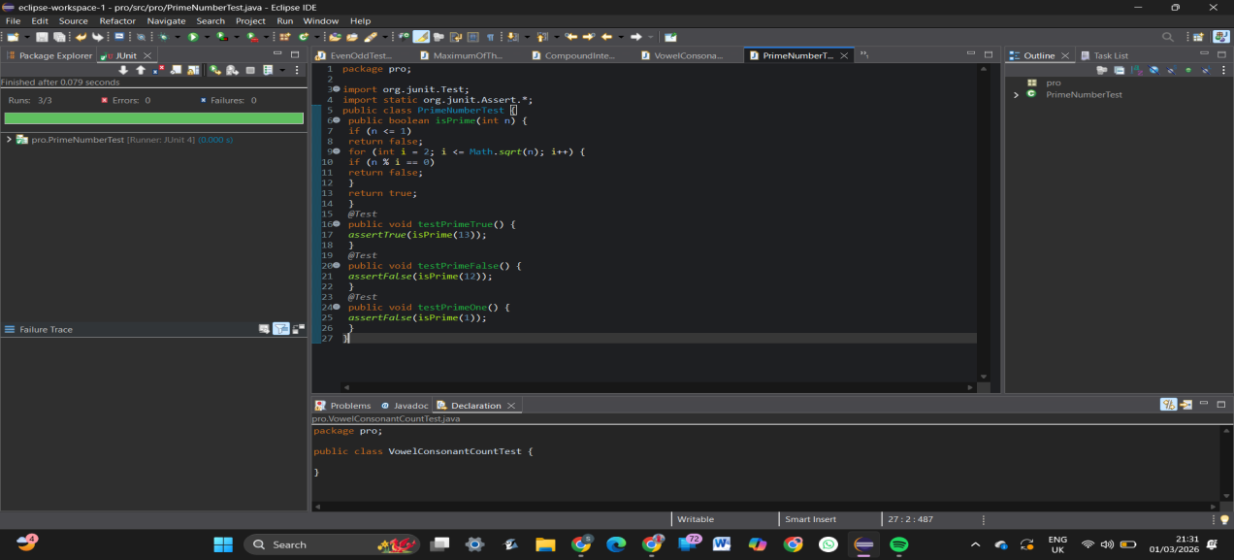
21.Prime Number Checking Using JUnit
22.Reverse a Number Using JUnit
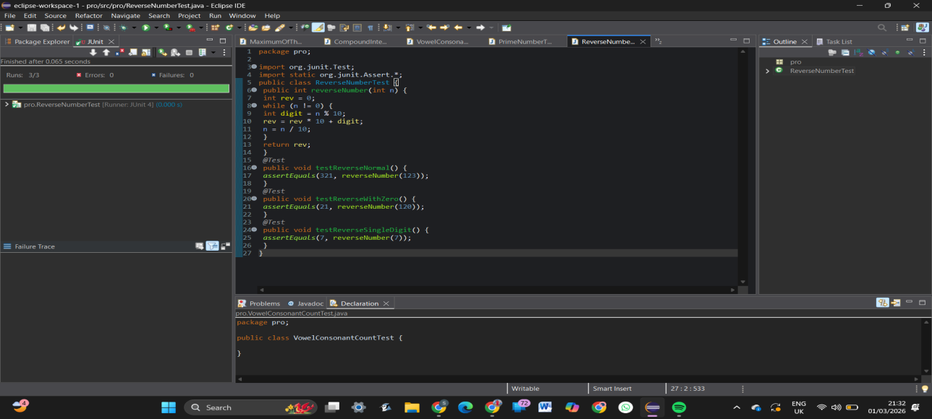
23.Sum of Digits of a Number Using JUnit
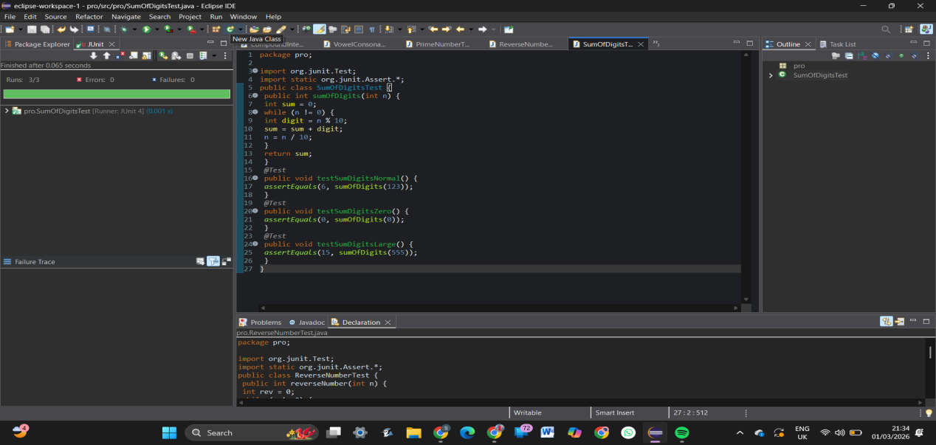
24.String Equality Ignoring Case Using JUnit
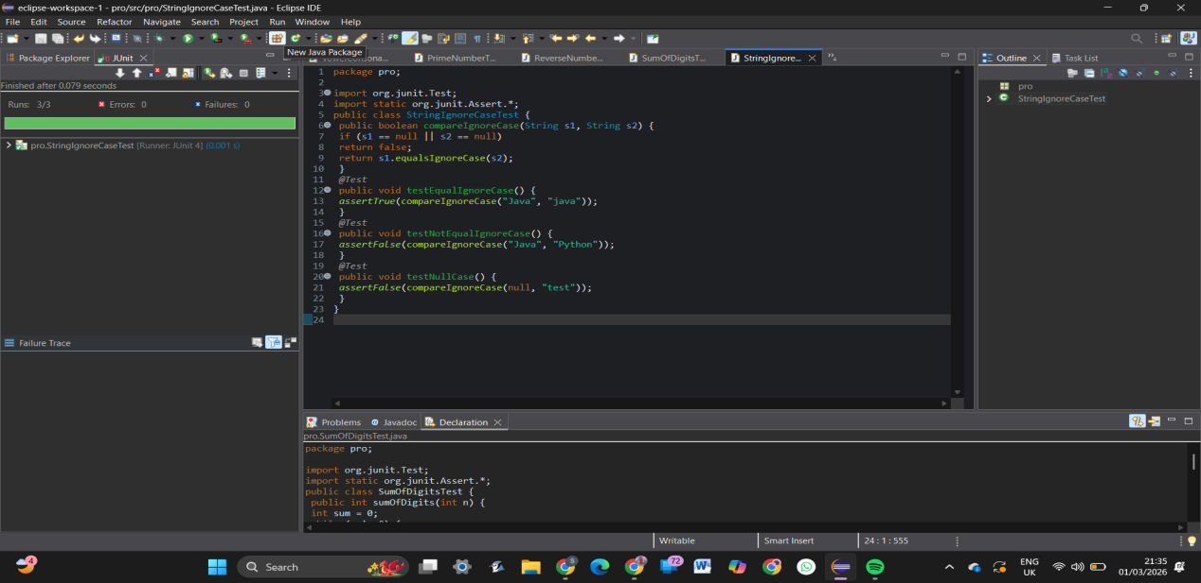
25.Student Grade Calculation Using JUnit
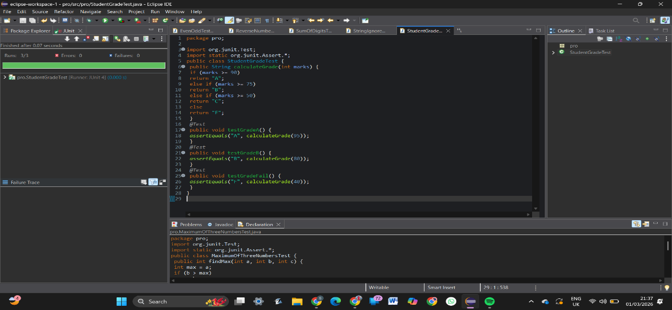
26.Find Largest Element in an Array Using JUnit
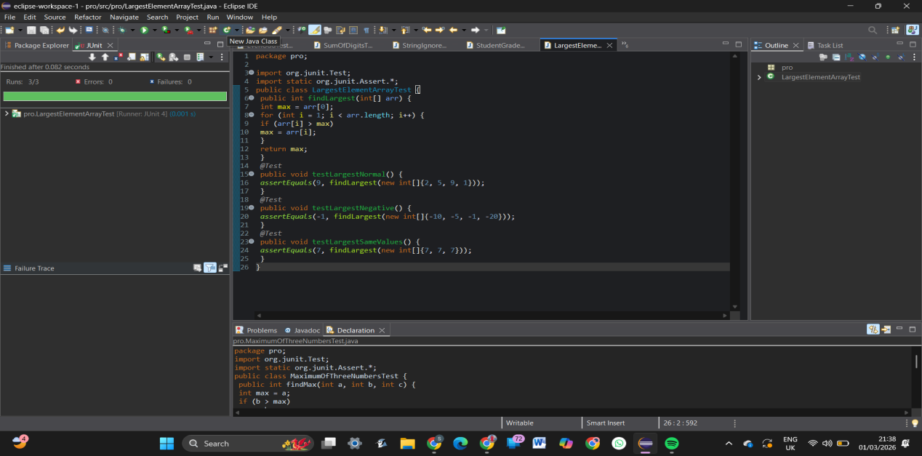
27.Calculate Average of N Numbers Using JUnit
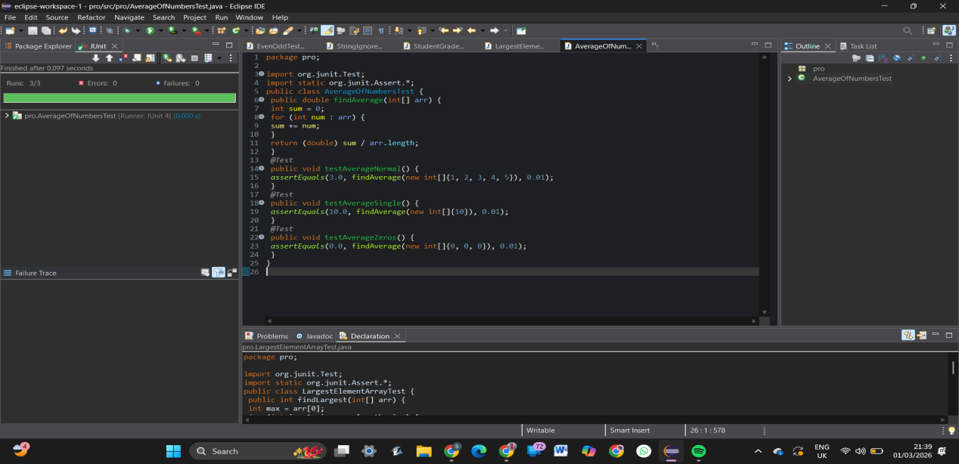
28.Check Armstrong Number Using JUnit
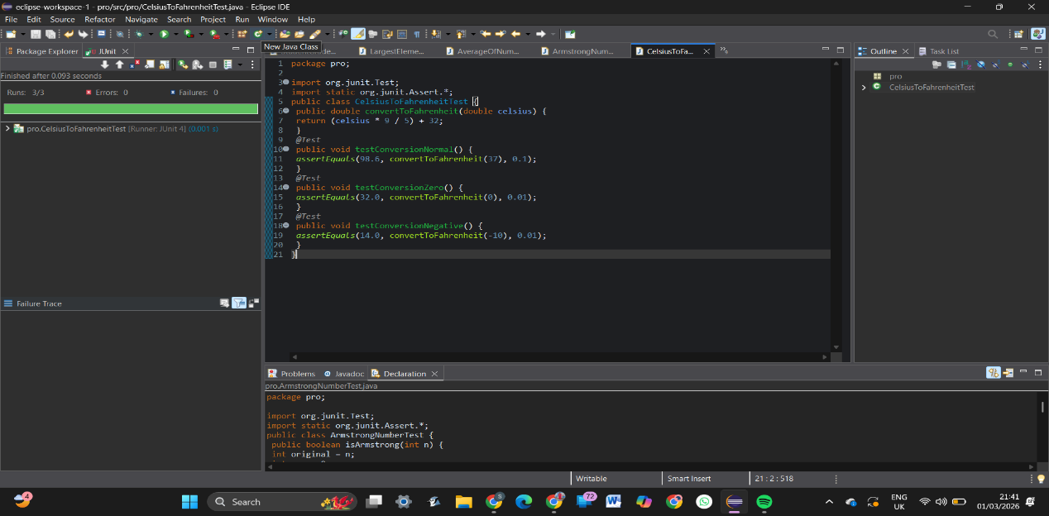
29.Convert Celsius to Fahrenheit Using JUnit
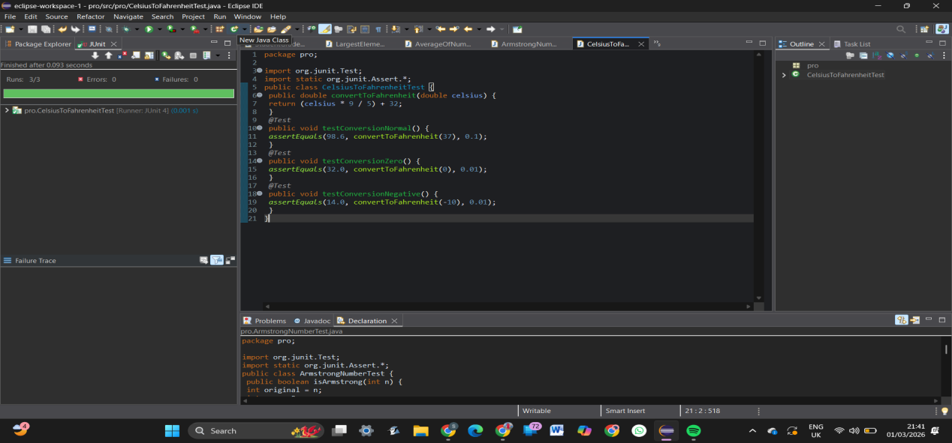
30.Find Length of a String Without Built-in Function Using JUnit
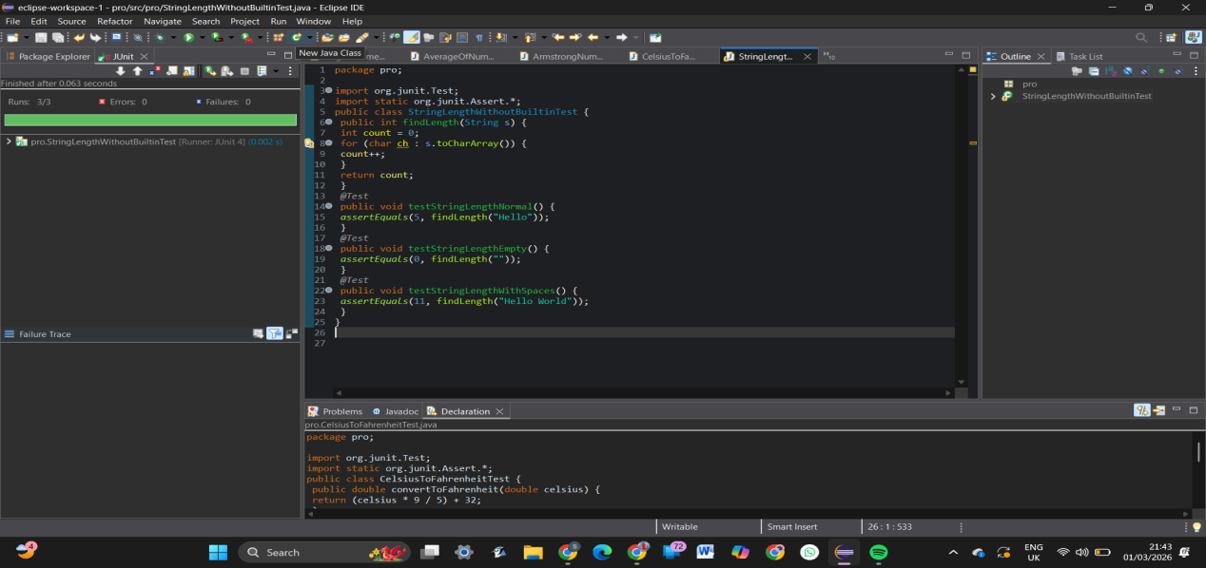
31.Reverse a Word Using JUnit
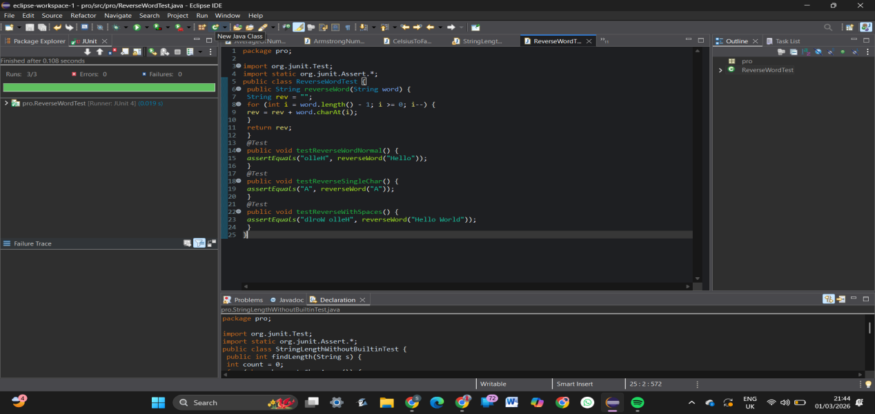
32.String Comparison Using JUnit
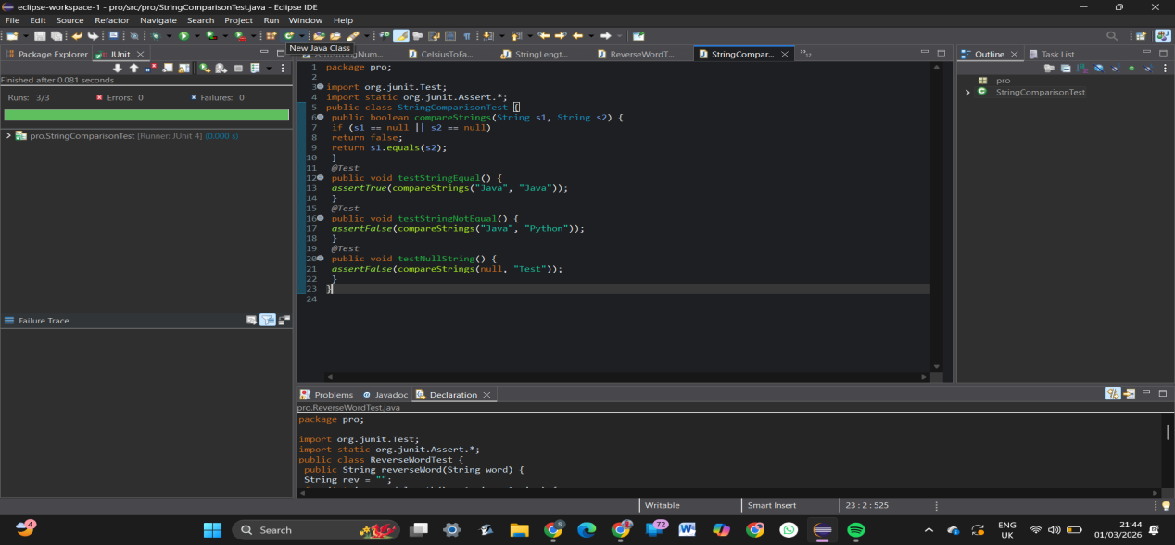
33.Voting System Using JUnit
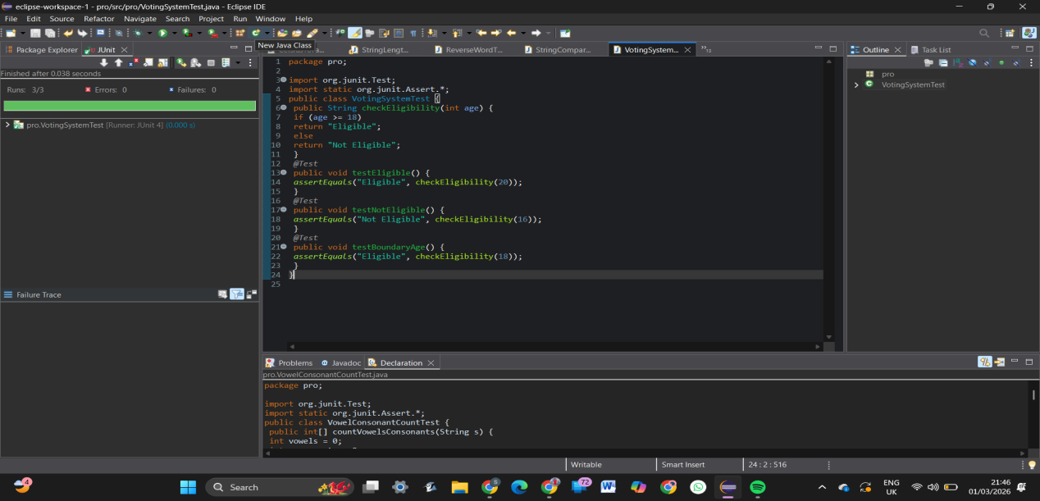
34.Simple Interest Calculation (Senior Citizen) Using JUnit
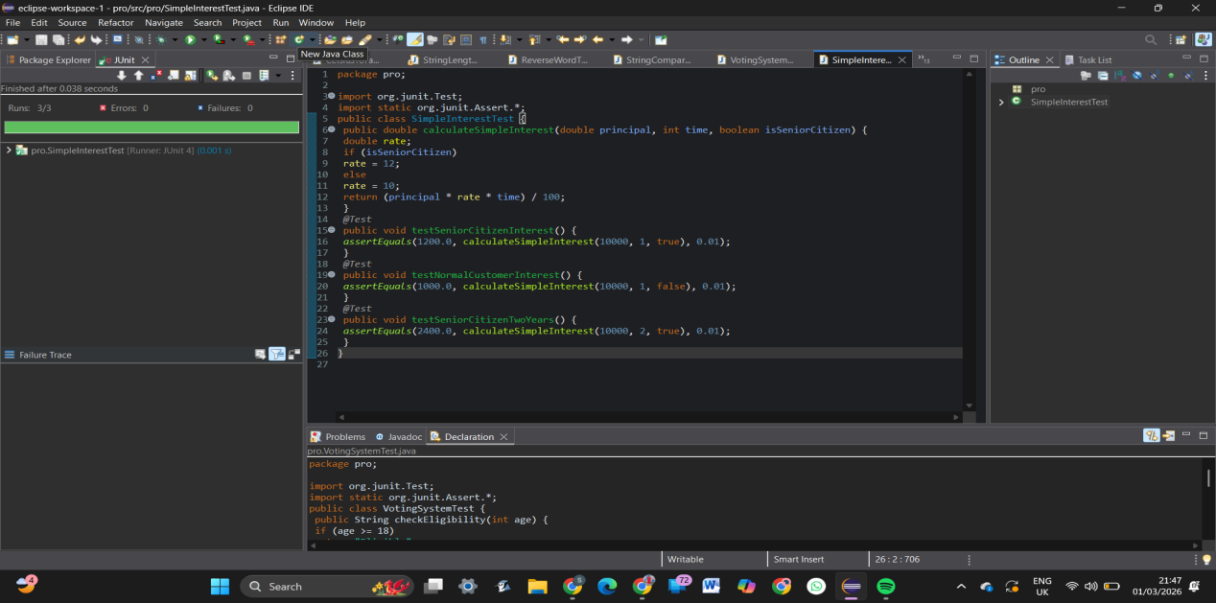
35.Palindrome Number Check Using JUnit